**Lab 3 – 21L6074**

**Syed Farhan Jafri**

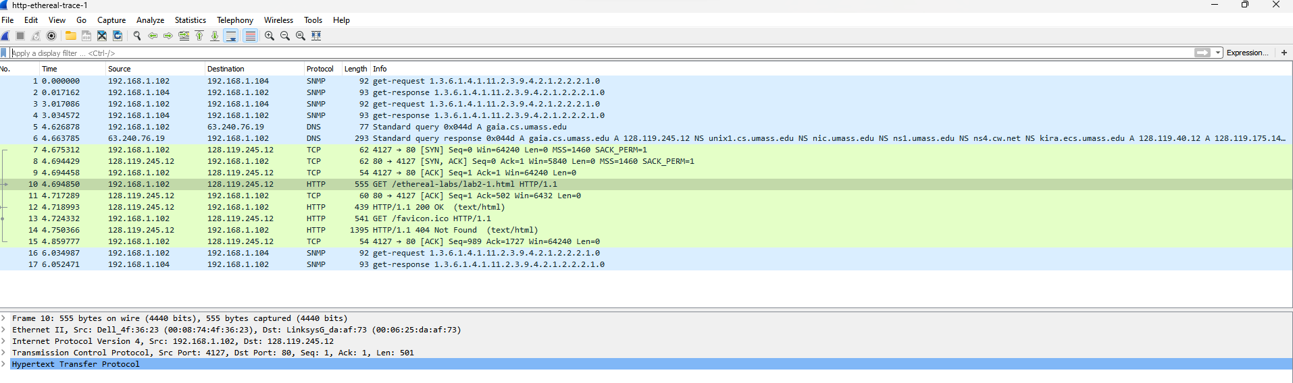**Q1a)**

1. **Protocols:** SNMP, TCP, HTTP, DNS
2. **Time Taken for GET and Reply:** 4.718993ms - 4.694850ms = 0.024143ms
3. **Second GET was not successful as error 404 not found pops up.**
4. **Browser is running Version 1.1 as shown in Info column.** (Screenshot in part 2 and 3)
5. **It uses en-us/English language.**
6. **IP address of gaia.cs.umass.edu server =** 128.119.245.12

**IP address of system =** 192.168.1.102

1. **MAC Address of System:** Dell_4f:36:23 (00:08:74:4f:36:23) **MAC Address of gaia.cs.umass.edu server:** LinksysG_da:af:73 (00:06:25:da:af:73)
2. **Sending Port =** 4127**, Receiving port =** 80Port 80 general port for HTTP traffic.
3. **Status code =** 200 OK  
   **Status code =** 404 Not Found (Screenshot in Part 2 and 3 Shown)
4.  **Last Modified =** Tue, 23 Sep 2003 05:29:50 GMT
5.  **Content Length =** 73

**Part 2**

1. **There is no IF-MODDED-SINCE Line.**
2. 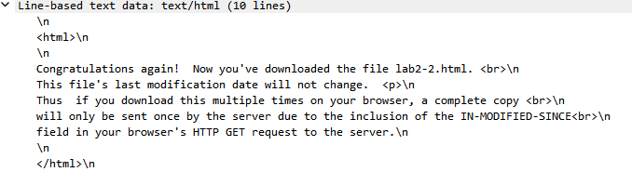**Yes, the server returned contents of the file.**
3. **Yes, there is a IF-MODDED-SINCE.**
4. **The Server did not respond, contents were not found.**

**Part 3**

1. **Only 1 HTTP GET Request was sent.**
2. **Packet 8 contains the GET message.**
3. **Packet 14 provides the Status code and phrase.**
4. **Status code in 200 and Phrase is OK** (Screenshot in part 7).
5. **4 packets are used. Packet 10, 11, 13, 14**